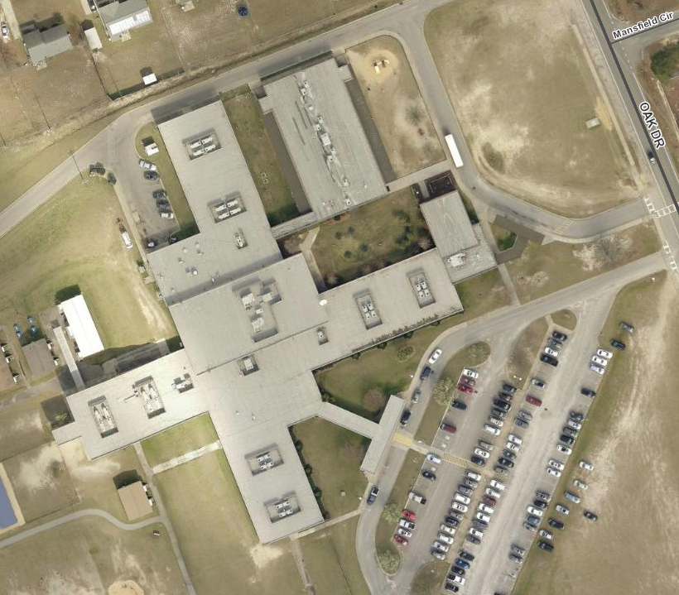

Map exercises

-Mountain Merkins X10 (IC)

-LBC X10 (IC)

-Squats X10 (IC)

*One rep added with each revolution

- Mosey

- Stairs

-Lunges

- Exercises on

the map

-Warm-up

- Start/Finish

Each revolution=

Stair count: 131

F3 Detention's

"Stairway To Heaven"

We shall leave no

stair untouched

"Stairway to Heaven"

We shall leave **no** stair untouched